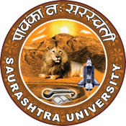

Celebration of World Earth Day
22 April 2022
At
NFDD Building
Saurashtra University Campus, Rajkot
Contents

Saurashtra University – IIC 2
Event Registration Link 2
Brief about Event 3
Outcome 3
Connect Us: 5

Saurashtra University – IIC
The university is dedicated to instruction, research, and extending knowledge to the public (public service). Ministry of Education (MoE), Govt. of India has established ‘MoE’s Innovation Cell (MIC)’ to systematically foster the culture of Innovation among all Higher Education Institutions (HEIs). The primary mandate of MIC is to encourage, inspire and nurture young students by supporting them to work with new ideas and transform them into prototypes while they are informative years. Saurashtra University is one the Organization that have constituted the IIC to foster the vision of MoE and be a part for the promotion and development of innovation ecosystem.

Event Registration Link

bit.ly/SUSEC-WED

Brief about Event

We had celebrated World Earth Day- 22 April 2022 to spared awareness about conserving earth by organizing a session on "Tree Plantation Program". Students and Faculty of Saurashtra University participated and celebrated World Earth Day enthusiastically.

The session was focus on how our earth is concerned and how it has been affected by Human Beings in last years and to give broad idea about current situation of Earth. This was an exclusive program for raise global awareness to take positive action for earth to protect nature and the planet earth.
The aim behind organizing this program was to give awareness to student about keeping the earth clean and safe from pollution. For this purpose, plant more trees to purify the air and make the earth green. Due to climate changes these are the sectors which will be affected most like people who is low-income communities affected the most, older people will be affected the most, children would be affected most.

Outcome

As per the event, various types of issues face by earth and how the temperature rises were understood. Students learn a lot about how to protect our earth and what are the solution for keeping safe our earth. The celebration helped students assimilate simply yet clearly that we should keep our environment clean and we should plant more trees for making active progress to Restore Our Earth.

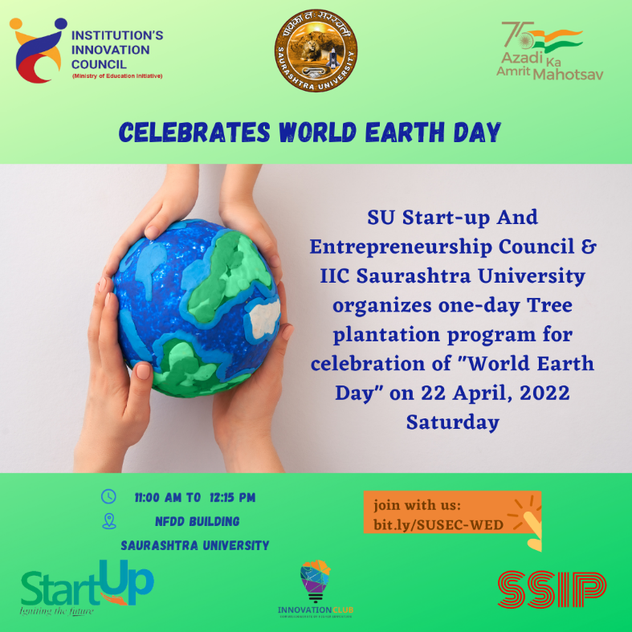

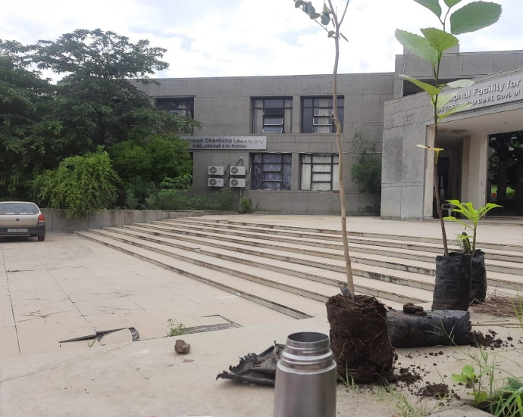
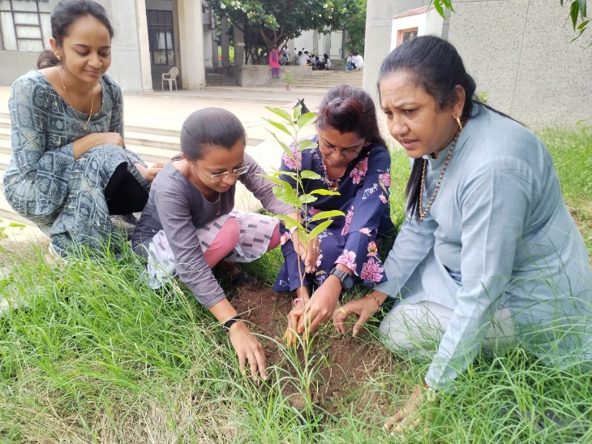

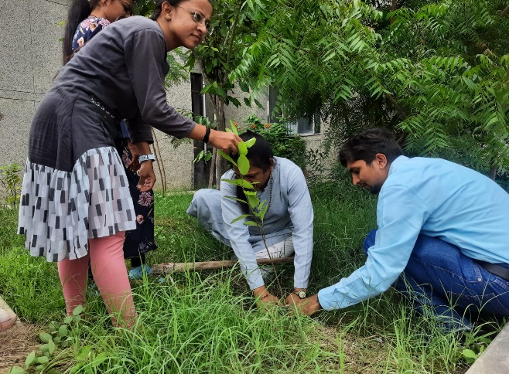
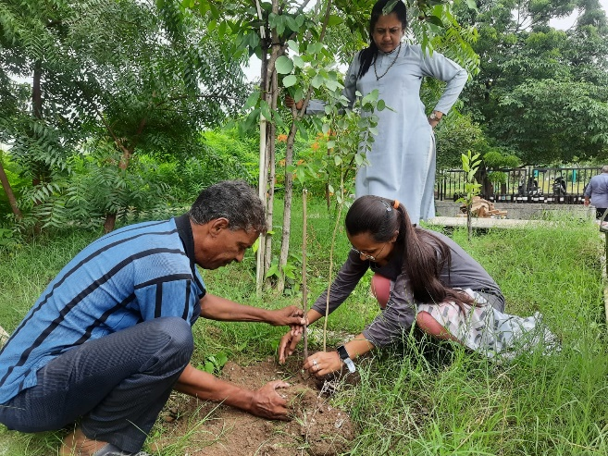

Connect Us:

https://www.linkedin.com/company/susec iic@sauuni.ac.in
https://www.facebook.com/iicsauuni bit.ly/SU-SSIP Location
https://www.instagram.com/susecrajkot https://bit.ly/SUSEC-youtube

